ANNUAL CRAFT FAIR

FEATURING

- INDIAN ARTS AND CRAFTS
- JEWELRY
- TABLE CENTERPIECES
- FEATURED ARTISTS
- STAR QUILTS
- MANY OTHER CRAFT BOOTHS

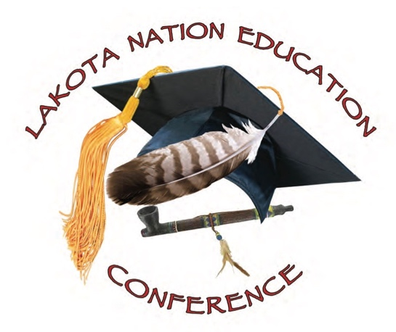

*********************************************
DECEMBER 18-20, 2019
RAMKOTA INN – RUSHMORE ROOM
(WEST OF MINERVAS RESTAURANT)

HOSTED BY THE LAKOTA NATIONS EDUCATION CONFERENCE.

EVERYONE IS WELCOME TO COME IN AND LOOK AROUND AND ENJOY THE BOOTHS AT NO CHARGE. PLEASE PLAN TO ATTEND!

